10.6: (a) The accompanying table illustrates the 16 possible pair combinations in the sample space. (b)Each of the 16 outcomes has probability 1/16.

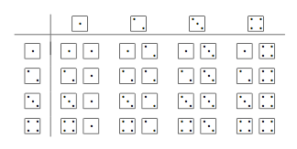

10.7: For the sample space, add 1 to each pair-total in the table shown in the previous solution: *S* = {3, 4, 5, 6, 7, 8, 9}. As all faces are equally likely and the dice are independent, each of the 16 possible pairings is equally likely, so (for example) the probability of a total of 5 is 3/16, because 3 pairings add to 4 (and then we add 1). The complete set of probabilities is shown in the table.

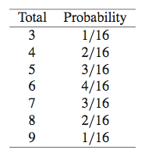

10.8: (a) 23% (17% + 6%) majored in engineering or science. This makes use of Rule 3, because (assuming there are no double majors) “undergraduate students in engineering” and “undergraduate students in science” have no students in common. (b) 47% (100% − 53%) did not major in business or commerce. This makes use of Rule 4.

10.44: (a) *X* is discrete, because it has a finite sample space. (b) “At least one nonword error” is the event {*X* ≥ 1} (or {*X* > 0}). *P*(*X* ≥ 1) = 1 − *P*(*X* = 0) = 0.9. (c) {*X* ≤ 2} is “no more than two nonword errors,” or “fewer than three nonword errors.” *P*(*X* ≤ 2) = *P*(*X* = 0) + *P*(*X* = 1) + *P*(*X* = 2) = 0.1 + 0.2 + 0.3 = 0.6. *P*(*X* < 2) = *P*(*X* = 0) + *P*(*X* = 1) = 0.1 + 0.2 = 0.3.